Final Year Project - UG

**School of Computing Science and Engineering (SCOPE)**

B.Tech. CSE/CPS/AL AND ML Capstone Project IN HOUSE Weekly Status Report – Week_04- 26.12.2022 to 30.12.2022

**Program: B.Tech. CSE/CPS/AI AND ML** **Batch: 2019-2023** **Course Code: CSE1904**

**Register No.: 19BAI1090 Name of the Student: ARNAB KARMAKAR Mobile No. 9721866757**

|  |  |  |  |  |  |  |  |
| --- | --- | --- | --- | --- | --- | --- | --- |
| **Project Title: STOCK MARKET PREDICTION USING MACHINE LEARNING** | | | | | | | |
| Technical Implementation Steps & Programming Tools:   1. Simple Convolutional Neural Network - construction and generation of synthetic data from user defined input. 2. Python libraries related to Deep Learning (eg TensorFlow, Keras, sklearn-theano). 3. Deep Learning (DL) libraries used for synthetic data generation that can work with both CPU and GPU | | | | | | | |
| **26.12.2022** | **Evaluate the True Positive and False Positive rate of the samples.** | | | | | | |
| **27.12.2022** | **Study, analyze and reduce the rate of False Positive samples through repetitive epochs.** | | | | | | |
| **28.12.2022** | **Study the x vs y plots of all parameters separately.** | | | | | | |
| **29.12.2022** | **Use the 4 – CNN Model to construct the plot of all features just used with each other and draw conclusions.** | | | | | | |
| **30.12.2022** | **Look for certain drawbacks and work on their rectification in further stages. Limitations may include the risk of data over - fitting,**  **/ Exceptional cases, and the difference in orientation of input data.** | | | | | | |
| **Implementation** | Patent / SCI / Scopus Indexed Journal Paper / Scopus Indexed Conference Paper/ Scopus  Indexed Book Chapter | | | | | | |
| **Work Status** | ***Excellent*** | ***/*** ***Good*** | ***/*** ***Satisfactory*** | | ***/*** ***Needs improve*** |  |  |
|  | | | | |  |  |
| ***Attendance Status*** | **Regular / Irregular** | | | ***CAM – Max. 5 Marks per week*** | |  |  |

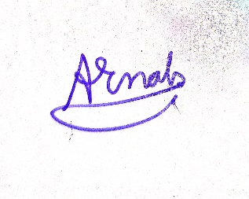

10/1/23

**Signature of the Student with date** **Name & Signature of the Guide with date**